Hexapod Robot With Articulated Body

**A.V. Panchenko1, V.E. Pavlovsky2, D.L. Sholomov3**

1,2KIAM RAS, Moscow, Russia

3ISA FRC CSC RAS, Moscow Russia

*E-mail: 1* [*panchenkoAV@vap.ru*](mailto:panchenkoAV@vap.ru)

*E-mail: 2* [*vlpavl@mail.ru*](mailto:vlpavl@mail.ru)

*E-mail: 3* [*sholomov@list.ru*](mailto:sholomov@list.ru)

**Abstract.**

The paper describes kinematic control for hexapod robot with three segment articulated body. Forward and inverse kinematics for articulated body studied. Static stability studied in case of climbing so called cliff obstacle. Necessary and sufficient conditions for stability during climbing sequence provided.

**Keywords:** Multi legged robot, obstacle climbing, articulated body.

INTRODUCTION

Study of walking machines is rather old question. Starting in

Ancient China [] primitive mechanical designs and finishing state of the art reinforcement learning [] and model predictive control [] results. Multilleged walking robots are very complicated systems in terms of control and planning due to number of degrees of freedom and actuators, complexity of the environment and so on. Nowadays the most complex and robust walking machines are made by Boston Dynamics company[]. Its robots are capable of working in human environment and outdoors. The basis of their solution is model predictive control and non-linear optimization. Their robots are based on the kinematics of mammals - dogs or horses. From the opposite, the kinematics of hexapod robots is based on insects and spiders.

The main idea of the article – conventional mainstream hexapods have rigid body with legs attached symmetrically. This arrangement has its limitations, as it was show in [] but still can be surprisingly agile and overcome complex obstacles as it was demonstrated in []. What if we add additional degrees of freedom – making multiple rigid segments to be a body instead of one rigid body segment. In common sense there would be trade off – the complexity of control will increase but the robot would climb up higher obstacles or do maneuvers that robots with rigid body are not capable of.

ROBOT KINEMATICS

Let us consider robot depicted on figure (). It has six so-called insectomorphic legs, i.e. insect like leg kinematics. Each leg has three degrees of freedom as shown on figure (). Body consists of three rigid segments connected with hinges to each other. Body that consists of several segments connected to each other with controllable joints and can change its geometry is called articulated.

The total number of degrees of freedom (d.o.f.) for specified robot is 26:

* 3 d.o.f. for each leg, i.e. 18 d.o.f. for all legs
* 2 d.o.f. for body segments
* 6 d.o.f. for the whole system as one single body

All in all it is 26 d.o.f. and 20 of them can be controlled with an actuators installed in corresponding rotational joints.

Let’s study the kinematics.

FORWARD BODY KINEMATICS

\\TODO

INVERSE BODY KINEMATICS

\\TODO

CLIFF OBSTACLE

Cliff obstacle consists of three planes two of which are horizontal and one is vertical as depicted on figure ().

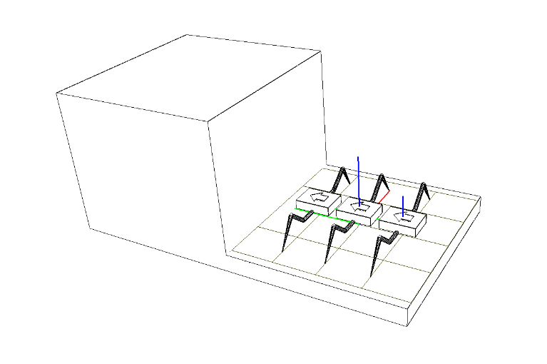

The distance between two horizontal planes is H. Robot starts from the lower horizontal plane and his goal is to climb up the higher horizontal plane using only the Coulomb friction.

To overcome cliff obstacle robot moves using so called gallop gait when a pair of symmetrical legs from left and right sides of the robot are in transition state and the others are in support state, i.e. in every moment of time there are four legs in contact with support planes.

STATIC STABILITY

The system is stable when sums of all external forces and all momentums are equal to zero.

$$\left\{\begin{matrix}\sum_{i=1}^{N}{{\overline{R}}_{i}}+\overline{P}=0 \\ \sum_{i=1}^{N}{\left[{\overline{r}}_{i}×{\overline{R}}_{i}\right]+\left[{\overline{r}}_{c}×\overline{P}\right]=0}\end{matrix}\right.$$

The following configurations of supporting legs displacement should be studied for static stability:

* All legs on the some horizontal plane. This case is already studied in []
* Front legs lean against the vertical plane and rear legs stand on the lower horizontal plane. Let us numerate this configuration number one.
* Front legs are placed at the upper horizontal plane, while the rear legs stand on the vertical plane. Lets numerate this configuration number two.
* All legs stand on the upper horizontal plane – this case is similar to the initial one.

Considering the system () as a slow moving system at every moment of time let’s find necessary conditions for static stability.

Reference frame *Oxyz* is defined as depicted on the figure ().

**Equations for first configuration**

Contact points of the legs for first configuration are as follows:

$$\begin{matrix}\begin{matrix}{\overline{r}}_{1}=\left(d,0,h\right), \\ {\overline{r}}_{2}=\left(-d,0,h\right),\end{matrix} \\ {\overline{r}}_{3}=\left(d,l,0\right), \\ {\overline{r}}_{4}=\left(-d,l,0\right).\end{matrix}$$

There is a reaction ${\overline{R}}_{i}$ acting on the robot leg at each contact point:

$${\overline{R}}_{i}= N_{i}{∙\overline{n}}_{i}+F_{τ}^{i}∙{\overline{τ}}_{i}+F_{ν}^{i}∙{\overline{ν}}_{i}$$

The ${\overline{τ}}_{i}$ and ${\overline{ν}}_{i}$ vectors have the following coordinates:

$$\begin{matrix}{\overline{ν}}_{1}=\left(1,0,0\right), \\ {\overline{ν}}_{2}=\left(1,0,0\right), \\ \begin{matrix}{\overline{ν}}_{3}=\left(1,0,0\right), \\ {\overline{ν}}_{4}=\left(1,0,0\right),\end{matrix}\end{matrix}\begin{matrix}{ \overline{τ}}_{1}=\left(0,0,1\right), \\ \begin{matrix}{ \overline{τ}}_{2}=\left(0,0,1\right), \\ { \overline{τ}}_{3}=\left(0,1,0\right),\end{matrix} \\ { \overline{τ}}_{4}=\left(0,1,0\right).\end{matrix}$$

The center of gravity has coordinates:

$${\overline{r}}_{c}=(0,y_{c},z_{c})$$

The gravity force $\overline{P}$ acts on the center of gravity of the robot:

$$\overline{P}=(0,0,-P)$$

The equations of static stability for first configuration are as follows:

$$\left\{\begin{matrix}\begin{matrix}F_{ν}^{1}+F_{ν}^{2}+F_{ν}^{3}+F_{ν}^{4}=0 \\ N_{1}+N_{2}+F_{τ}^{3}+F_{τ}^{4}=0 \\ F_{τ}^{1}+F_{τ}^{2}+N_{3}+N_{4}=P\end{matrix} \\ \begin{matrix}{(N}_{1}+N_{2})h+Py_{c}=l(N_{3}+N_{4}) \\ d\left(F_{τ}^{1}-F_{τ}^{2}+N_{3}-N_{4}\right)=h(F_{ν}^{1}+F_{ν}^{2}) \\ d\left(N_{1}-N_{2}+F_{τ}^{3}-F_{τ}^{4}\right)=l(F_{ν}^{3}+F_{ν}^{4})\end{matrix}\end{matrix}\right.$$

The total number of equation is six. The number of unknown variables is twelve. Let’s assume that the friction forces are modelled with Coulomb mathematical model:

$F_{i}=kN_{i}$, where k is coefficient of friction and $0<k<1$.

After substitution of the Coulomb friction model, the equations will transform into the following system:

$$\left\{\begin{matrix}\begin{matrix}N_{1}k_{ν}^{1}+N_{2}k_{ν}^{2}+N_{3}k_{ν}^{3}+N_{4}k_{ν}^{4}=0 \\ N_{1}+N_{2}+N_{3}k_{τ}^{3}+N_{4}k_{τ}^{4}=0 \\ N_{1}k_{τ}^{1}+N_{2}k_{τ}^{2}{+N}_{3}+N_{4}=P\end{matrix} \\ \begin{matrix}{(N}_{1}+N_{2})h+Py_{c}=l(N_{3}+N_{4}) \\ d\left(N_{1}k_{τ}^{1}-N_{2}k_{τ}^{2}+N_{3}-N_{4}\right)=h(N_{1}k_{ν}^{1}+N_{2}k_{ν}^{2}) \\ d\left(N_{1}-N_{2}+N_{3}k_{τ}^{3}-N_{4}k_{τ}^{4}\right)=l(N_{3}k_{ν}^{3}+N_{4}k_{ν}^{4})\end{matrix}\end{matrix}\right.$$

The number of unknowns variables is still the same, and besides $N_{i}>0$. Let’s introduce additional assumptions that the left and the right side of the robot are loaded equally and coefficients of friction are the same between left and right legs:

$$\left\{\begin{matrix}\begin{matrix}k_{ν}^{1}=-k_{ν}^{2}=k_{ν} \\ k_{ν}^{3}=-k_{ν}^{4}=k_{ν} \\ k_{τ}^{1}=k_{τ}^{2}=k_{τ}^{u}\end{matrix} \\ \begin{matrix}k_{τ}^{3}=k_{τ}^{4}=k_{τ}^{d} \\ N_{1}=N_{2}=N_{u} \\ N_{3}=N_{4}=N_{d}\end{matrix}\end{matrix}\right.$$

Finally, the system of three equations and four variables obtained:

$$\left\{\begin{matrix}N_{u}+N_{d}k_{τ}^{d}=0 \\ 2N_{d}+2N_{u}k_{τ}^{u}=P \\ 2hN_{u}+Py_{c}=2lN_{d}\end{matrix}\right.$$

Number of unknowns is still greater than number of equations. One more assumption must be introduced:

$$k_{τ}^{u}=-k_{τ}^{d}=k>0$$

Finally, the system of three equations and three unknowns obtained:

$$\left\{\begin{matrix}N_{u}-N_{d}k=0 \\ 2N_{d}+2N_{u}k=P \\ 2hN_{u}+Py_{c}=2lN_{d}\end{matrix}\right.$$

Let’s find unknown reactions $N_{u},N_{d}$ and $k$. From first and second equations of () follows:

$$\begin{matrix}N_{d}=\frac{P}{2(1+k^{2})} \\ N_{u}= \frac{kP}{2(1+k^{2})}\end{matrix}$$

After substituting () to the third equation of () we have quadratic equation relative to $k$:

$$y_{c}k^{2}+hk+\left(y_{c}-l\right)=0$$

There are two solutions for quadratic equation ():

$$k_{1,2}= -\frac{h ±\sqrt{h^{2}-4y_{c}^{2}+4ly_{c}}}{2y_{c}}$$

To make robot able to climb up the cliff without any hooks and adhesive forces the friction coefficient $k$ must satisfy the condition $0 < k < 1$. It is easy to show that taking into account the configuration conditions () only solution $k_{1}$

$$k_{1}= -\frac{h- \sqrt{h^{2}-4y_{c}^{2}+4ly_{c}}}{2y_{c}}>0$$

meets the requirement $k>0$. The $k_{2}$ solution is always less than zero. Lets study when the $k<1$ is fulfilled for $k_{1}$. To study this three dimensional parametric space the following dimensionless parameters will be introduced.

**Dimensionless parameters**

It is easy to see that the expression () for $k$ depends on $l,h$ and $y_{c}$ parameters that are measured in meters – they all have the same physical dimension. Let us use this circumstance and define the following dimensionless parameters:

$$\begin{matrix}p_{1}≔\frac{h}{y_{c}}, \\ p_{2}≔\frac{l}{y_{c}}.\end{matrix}, where y_{c}≠0$$

After substitution of () into the expressions for $k_{1}$ we get the following inequality:

$$0< -\frac{1}{2}p_{1}+\sqrt{\frac{1}{4}p_{1}^{2}+p_{2}-1}<1$$

Inequality is equivalent to the following system:

$$\left\{\begin{matrix}p_{1}^{2}+4p_{2}-4 ≥0 \\ p_{2}-2-p_{1}<0\end{matrix}\right., where p_{1}>0 and p_{2}>0$$

The solution of system () is depicted on figure ().

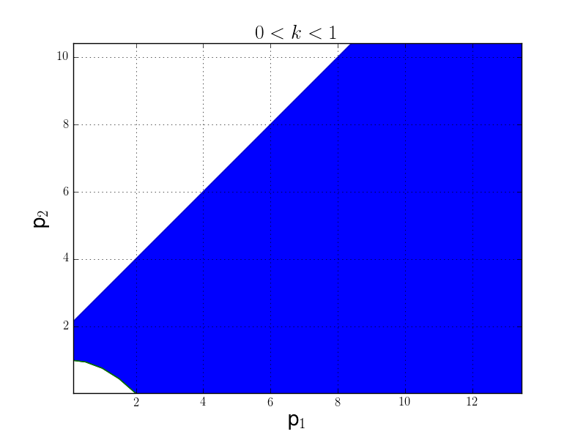

From figure () it becomes clear that if there is lack of friction in contact points the robot should:

* move its center of gravity closer to the rear pare of legs
* choose contact points higher on the vertical plane for front legs
* choose contact points closer to vertical plane for rear legs

**Equations for second configuration**

Leg contact points for the second configuration are:

$$\begin{matrix}\begin{matrix}{\overline{r}}_{1}=\left(d,l,H\right), \\ {\overline{r}}_{2}=\left(-d,l,H\right),\end{matrix} \\ {\overline{r}}_{3}=\left(d,0,h\right), \\ {\overline{r}}_{4}=\left(-d,0,h\right).\end{matrix}$$

Parameters $l<0$, $H>h$ and besides always $y_{c}>l$.

Similarly, for the second configuration we get the following system of three equations:

$$\left\{\begin{matrix}N_{u}-N_{d}k=0 \\ 2N_{u}+2N_{d}k=P \\ 2N_{d}h+Py_{c}=2N_{u}(l+Hk)\end{matrix}\right.$$

There are two possible solutions for $k$:

$$\begin{matrix}k_{1}= \frac{\left(H-h\right)+ \sqrt{{(H-h)}^{2}-4y_{c}^{2}+4ly_{c}}}{2y_{c}} \\ k_{2}= \frac{\left(H-h\right)- \sqrt{{(H-h)}^{2}-4y_{c}^{2}+4ly_{c}}}{2y_{c}}\end{matrix}$$

It is easy to see that this time $y_{c}$ can change its sign because of center of gravity transition above the upper edge of the cliff and because of that, the solution $k_{1}$ does not fulfill the $k_{1}>0$ requirement. On the other hand, solution $k_{2}$ meets the requirement $k_{2}>0$ for every $y_{c}>l.$

Let’s find solution of inequality $k_{2}<1$ using the following dimensionless parameters:

$$\begin{matrix}p_{1}≔ \frac{\left(H-h\right)}{y_{c}} \\ p_{2}≔ \frac{l}{y_{c}}\end{matrix}, where y_{c}≠0$$

The solution for $k_{2}$ exists:

$$p_{2}<2-p_{1}$$

Taking into account the domain of definition for square root from (), the solution for inequality () in dimensionless space is depicted on the following figure:

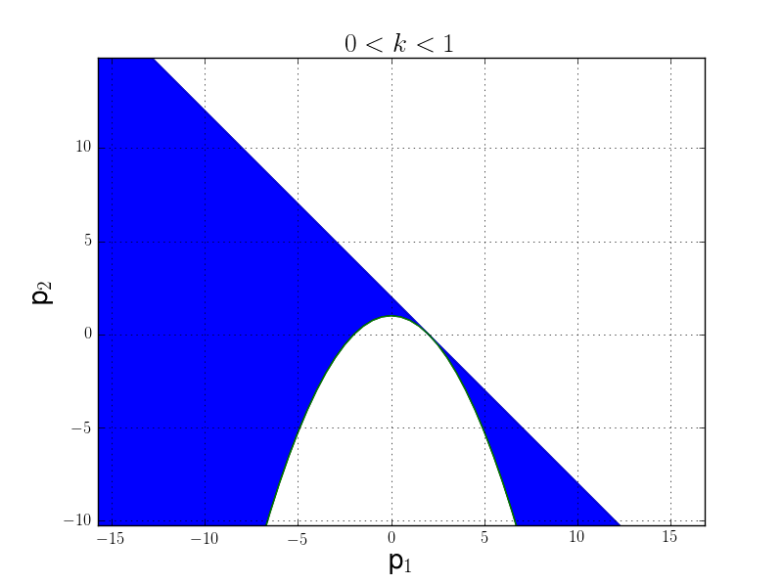

From figure () it can be shown that to reduce the value of $k$ the robot should:

* keep its center of gravity closer to front legs
* keep rear legs as higher as possible
* keep front legs farther from edge of cliff

We have considered the second configuration in assumtiontion that $y_{c}≠0$. Let’s see what happens when center of gravity is right above the cliffs adge in second configuration.

**Second configuration. $y_{c}$ equals to zero**

If the $y_{c}$ = 0 the equations of static stability () will transform into the following system:

$$\left\{\begin{matrix}N_{d}-N_{u}k=0 \\ 2N_{u}+2N_{d}k=P \\ N_{d}h=N_{u}(l+Hk)\end{matrix}\right.$$

There is only one solution for $k$ for system ():

$$k= -\frac{l}{(H-h)}$$

Due to condition () the expression for $k$ is always greater than zero. From the other side, the requirement $k<1$ is eqvivalent to the following inequality:

$$0<-l<\left(H-h\right), where l<0$$

Inequality () means that to provide stable configuration in case when $y_{c}=0$ the contact points should be chosen in a way, that the front legs should be closer to cliff edge than the rear legs.

CONCLUSION

The analisys of the robot configurations in different poses on the cliff proved that stable qusistatic motion is possible for all steps, i.e. the robot is capble of climbing the cliff with static stability preservation using only Columb friction forces.

**ACKNOWLEDGEMENTS**

The research work is supported by the Russian Foundation for Basic Reseach. The unique project number is 16-31-00524 mol_a.

**REFERENCES**

1. Nfaoui H, Buret J, Sayigh A.A.A., Wind characteristics and wind energy potential in Morocco. Solar Energy 1998; 63(1):51-60.
2. Daoo VJ, Panchal NS, Faby S, Sitaram V, Krishnamoorthy TM. Assessment of wind energy potential of Trombay, Mumbai, India. Energy Convers. Mgmt. 1998; 39(13):1351-1356.
3. Nayar CV, Thomas FP, Phillips SJ, James WL.,Design considerations for appropriate wind energy systems in developing countries. Renewable Energy 1991;1( 5/6): 713-22.
4. Bellarmine TG, Joe U.,Wind energy for the 1990s and beyond. Energy Convers. Management 1996; 37(12) : 1741-52.
5. Randall Swisher and Paul Gipe 1992: "U.S. Windfarms: An Expanding Market",Solar Today, November/December, pp. 17-19, 1992.
6. Mir-Akbar H and David R. B. Economic feasibility and optimization of an energy storage system for Portland Wind Farm (Victoria, Australia). *Applied Energy* 2011: 88: 2756-2763
7. <http://www.gwec.net/wp-content/uploads/2015/02/GWEC_GlobalWindStats2014_FINAL_10.2.2015.pdf>
8. Jiwoong P., Jeongil K., Youndho S., Jeongoon L., and Jongpo P., 3 MW class wind turbine development *Current Applied Physics* 2010: 10: 307-310.
9. Scott V. V. Sheltering wind power projects from tempestuous community concerns. *Energy for Sustainable Development* 2011: 15: 109-114.
10. Albadi M. H., El-Saadany E.F., and Albadi.A., Wind to power a new city in Oman. *Energy* 2009: 34: 1579-1586
11. Raymond M.W. Wind energy development in the Caribbean. *Renewable Energy* 2001: 24: 439-444